STEP 1: Create the React App
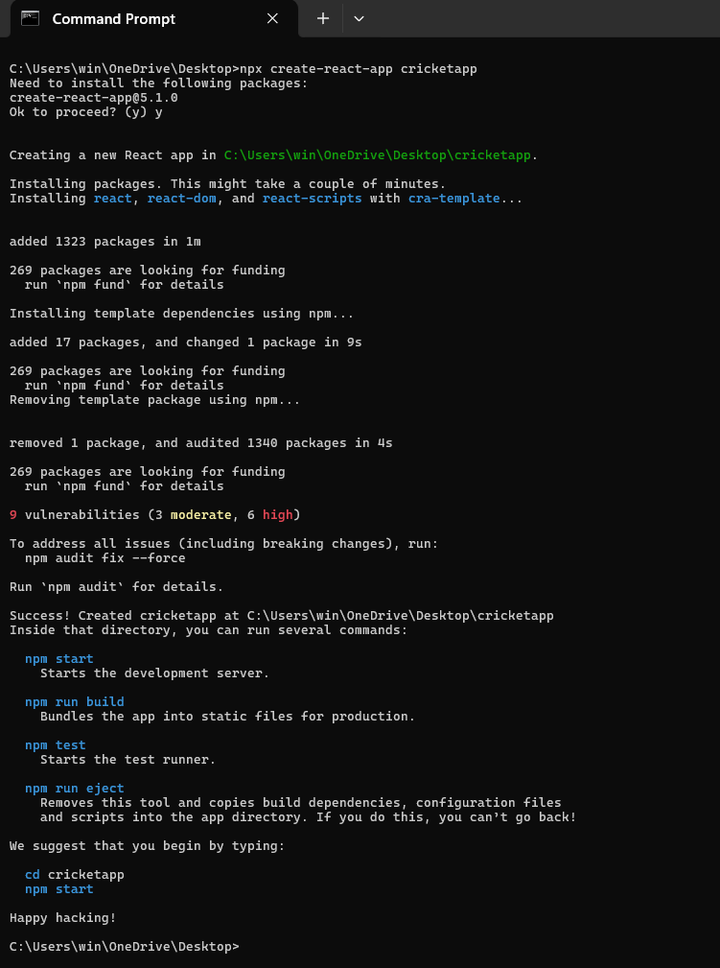

STEP 2: Create Components
Inside src/, create:
- ListofPlayers.js
- IndianPlayers.js
Also, modify App.js to control which component is shown using a flag.
STEP 3: Create ListofPlayers Component
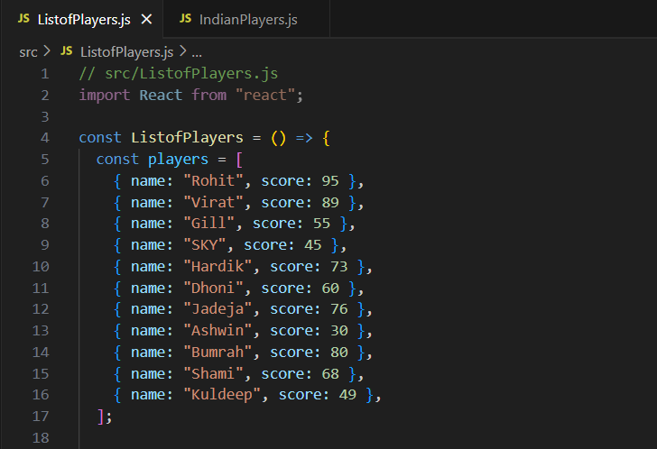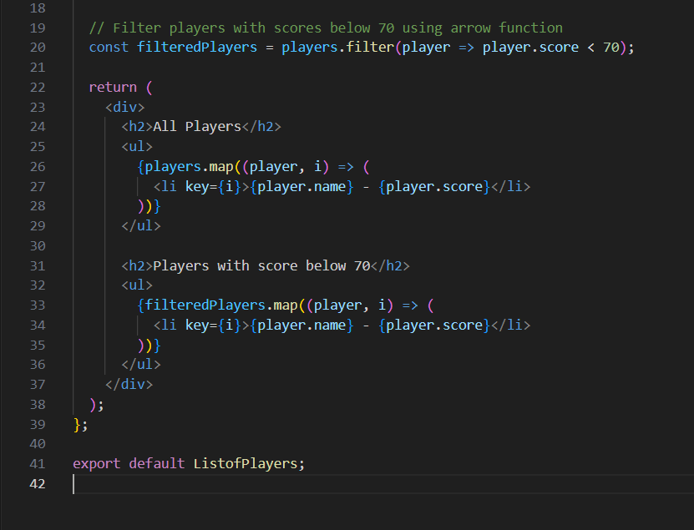
STEP 4: Create IndianPlayers Component
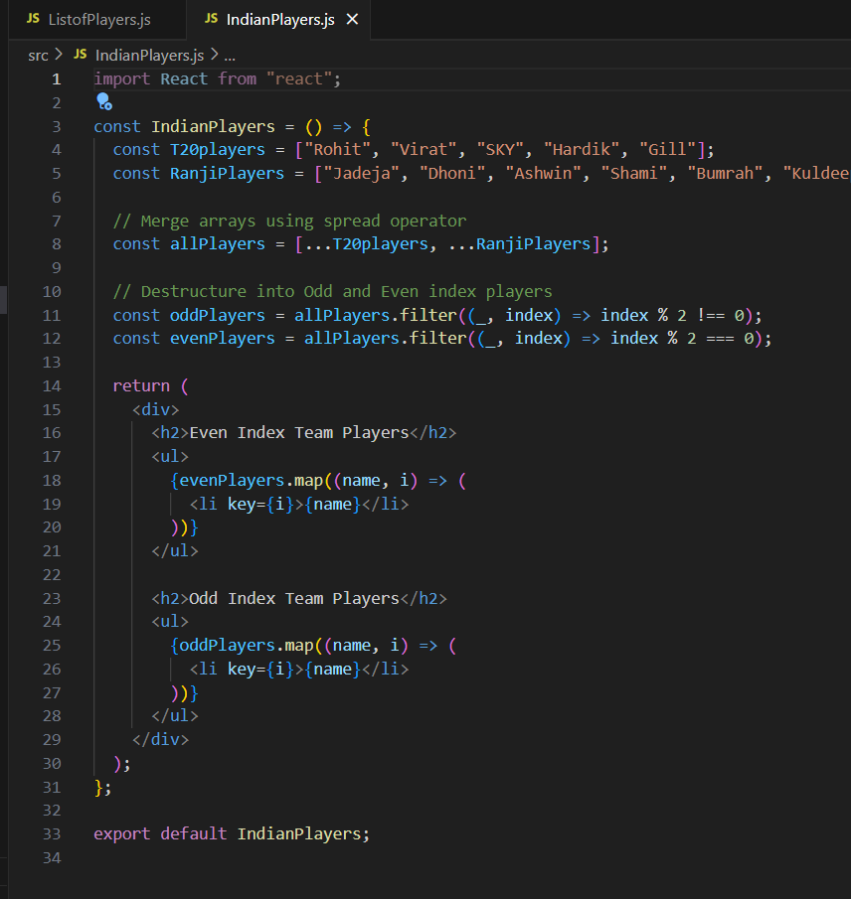
STEP 6: Modify App.js to toggle between components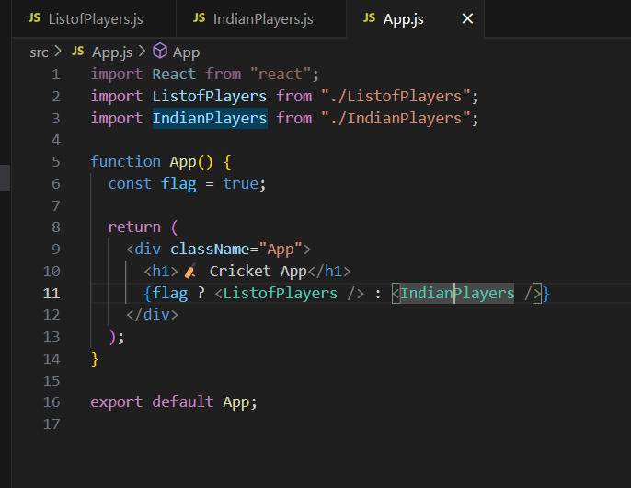

STEP 7: Run Your App
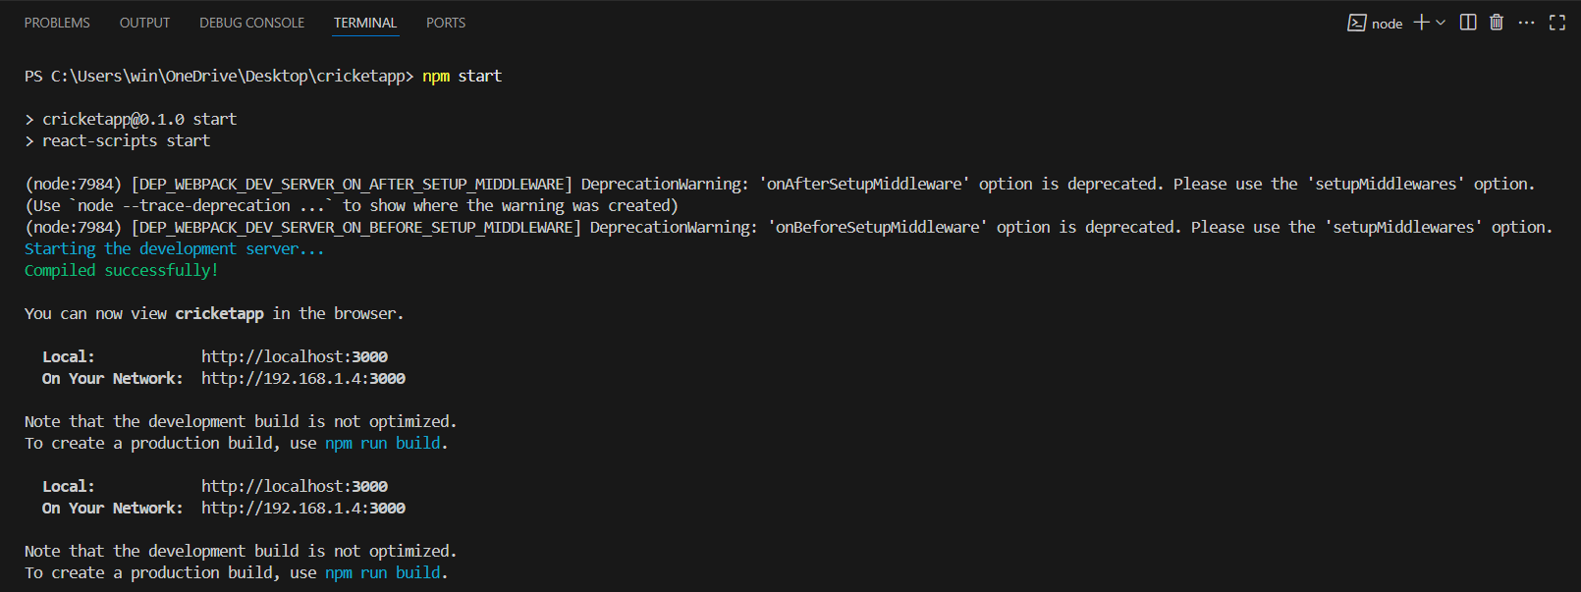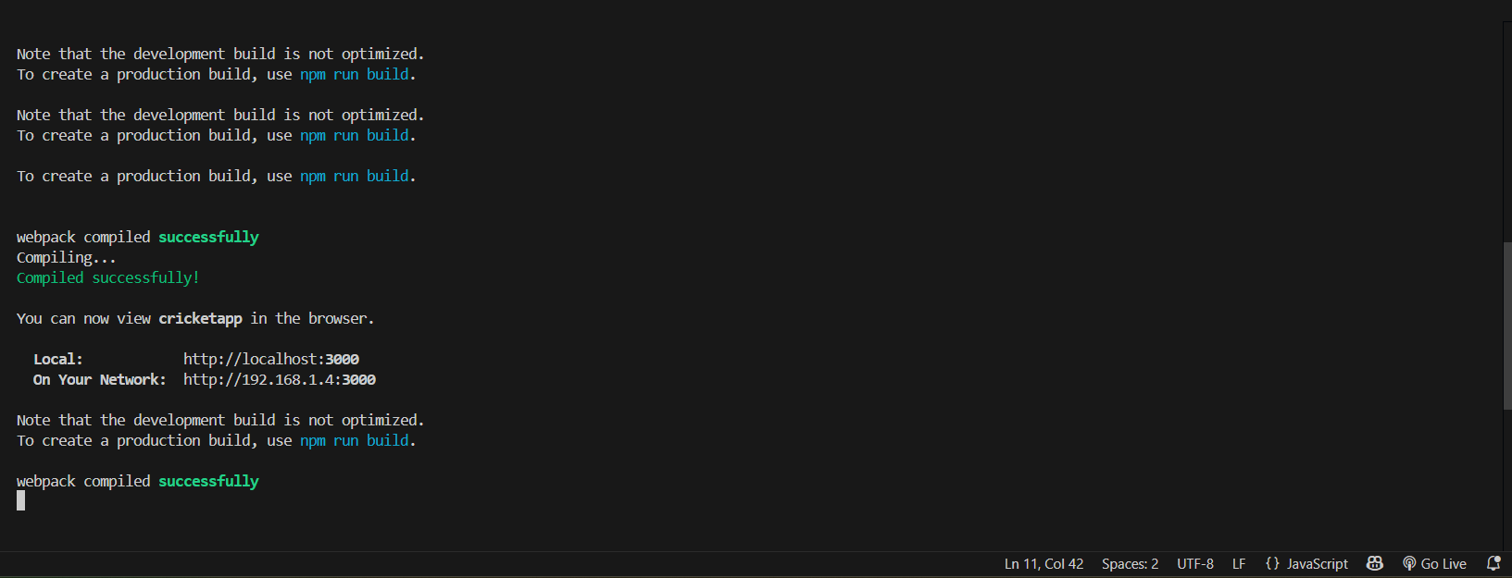

Output:
